DATA MINING
Day 3 Exercises — Solved Record
Association Rule Mining (Apriori & FP-Growth) · Bayesian & Decision-Tree Classification · Regression Analysis · WEKA Implementation

Exercise 1 — Apriori & FP-Growth: Customer Transactions
Problem: Consider the customer transaction dataset below. Perform the Apriori Algorithm and FP-Growth Algorithm with support = 3 (i.e. minimum support count of 3 out of 10 transactions) and confidence = 50%.

Dataset
Customer ID | Transaction ID | Items Bought
1 | 0001 | {a, d, e}
1 | 0024 | {a, b, c, e}
2 | 0012 | {a, b, d, e}
2 | 0031 | {a, c, d, e}
3 | 0015 | {b, c, e}
3 | 0022 | {b, d, e}
4 | 0029 | {c, d}
4 | 0040 | {a, b, c}
5 | 0033 | {a, d, e}
5 | 0038 | {a, b, e}

Step 1 — Apriori: Frequent Itemset Generation
Item counts (L1): a=7, b=6, c=5, d=6, e=8 — all meet minsup=3, so all five single items are frequent.
Level | Frequent Itemsets (support count)
L1 | a(7), b(6), c(5), d(6), e(8)
L2 | ab(4), ac(3), ad(4), ae(6), bc(3), be(5), ce(3), de(5) — bd(2) and cd(2) pruned (below minsup)
L3 | abe(3), ade(4) — abc(2), ace(2), bce(2) pruned
L4 | none — candidate abde pruned because subset abd is not frequent
Total frequent itemsets = 5 (L1) + 8 (L2) + 2 (L3) = 15.

Step 2 — Association Rules (confidence ≥ 50%)
Generating all antecedent → consequent splits of every frequent itemset of size ≥ 2 and keeping only those with confidence ≥ 50% yields 24 rules:
# | Rule | Support | Confidence
1 | a, d → e | 40% | 100%
2 | a → e | 60% | 85.71%
3 | b → e | 50% | 83.33%
4 | d → e | 50% | 83.33%
5 | d, e → a | 40% | 80%
6 | a, b → e | 30% | 75%
7 | e → a | 60% | 75%
8 | a, e → d | 40% | 66.67%
9 | b → a | 40% | 66.67%
10 | d → a | 40% | 66.67%
11 | d → a, e | 40% | 66.67%
12 | e → d | 50% | 62.5%
13 | e → b | 50% | 62.5%
14 | b, e → a | 30% | 60%
15 | c → b | 30% | 60%
16 | c → e | 30% | 60%
17 | c → a | 30% | 60%
18 | a → b | 40% | 57.14%
19 | a → d | 40% | 57.14%
20 | a → d, e | 40% | 57.14%
21 | a, e → b | 30% | 50%
22 | b → c | 30% | 50%
23 | b → a, e | 30% | 50%
24 | e → a, d | 40% | 50%

Step 3 — FP-Growth Tree
Item ordering by descending frequency: e(8) > a(7) > b(6) = d(6) > c(5). Each transaction is reordered accordingly and inserted into the tree, sharing prefixes:
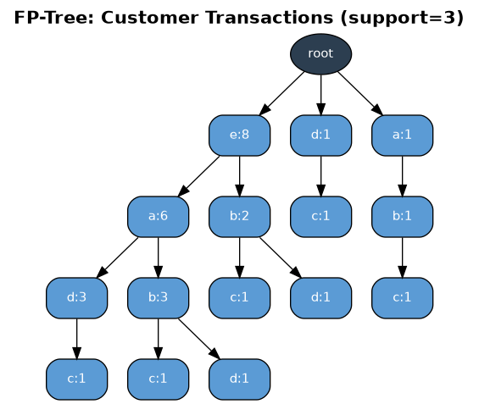
Figure 1.1 — FP-Tree built from the customer transaction dataset (support = 3).
Reading the tree top-down from any leaf back to the root gives the conditional pattern bases used to mine the same frequent itemsets found by Apriori above (e.g. the path root→e→a→d→c confirms itemset {a,d,e} and its subsets).

WEKA Output (illustrative)
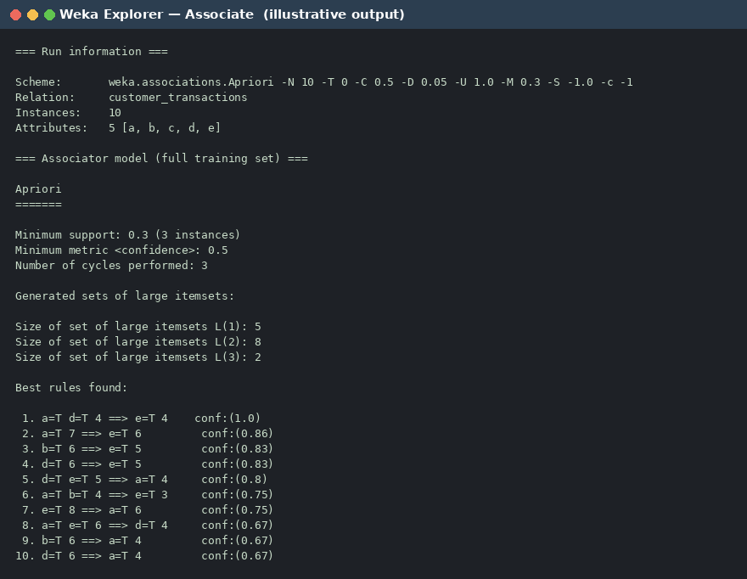
Figure 1.2 — Associate tab (Apriori), minSupport = 0.3, minConfidence = 0.5.

Exercise 2 — Market-Basket Dataset: Apriori/FP-Growth & Theory Questions
Problem: Consider the market-basket transactions below (support = 3, confidence = 50%). (a) What is the maximum number of association rules that can be extracted from this data, including rules with zero support? (b) What is the maximum size of a frequent itemset that can be extracted, assuming minsup > 0?

Dataset
Transaction ID | Items Bought
1 | {Milk, Beer, Diapers}
2 | {Bread, Butter, Milk}
3 | {Milk, Diapers, Cookies}
4 | {Bread, Butter, Cookies}
5 | {Beer, Cookies, Diapers}
6 | {Milk, Diapers, Bread, Butter}
7 | {Bread, Butter, Diapers}
8 | {Beer, Diapers}
9 | {Milk, Diapers, Bread, Butter}
10 | {Beer, Cookies}

(a) Maximum number of association rules
With d = 6 distinct items (Milk, Beer, Diapers, Bread, Butter, Cookies), the maximum number of association rules — including those with zero support — is given by:
R = 3ᵈ − 2^(d+1) + 1
Substituting d = 6: R = 3⁶ − 2⁷ + 1 = 729 − 128 + 1 = 602 rules.

(b) Maximum size of a frequent itemset
A frequent itemset can never be larger than the largest transaction in the dataset, because every subset of a transaction is at most as long as the transaction itself. The longest transaction here is {Milk, Diapers, Bread, Butter} (transactions 6 and 9), which has 4 items. Hence the maximum possible frequent-itemset size (for any minsup > 0) is 4.

Apriori — Frequent Itemsets (support = 3, confidence = 50%)
Level | Frequent Itemsets (support count)
L1 | Milk(5), Beer(4), Diapers(7), Bread(5), Butter(5), Cookies(4)
L2 | Beer-Diapers(3), Bread-Butter(5), Bread-Diapers(3), Bread-Milk(3), Butter-Diapers(3), Butter-Milk(3), Diapers-Milk(4)
L3 | Bread-Butter-Diapers(3), Bread-Butter-Milk(3)
Total frequent itemsets = 6 + 7 + 2 = 15 (well under the theoretical maximum of 602 possible rules — most candidates fail the minsup=3 cut).

Association Rules (confidence ≥ 50%)
# | Rule | Support | Confidence
1 | Butter → Bread | 50% | 100%
2 | Bread → Butter | 50% | 100%
3 | Butter, Diapers → Bread | 30% | 100%
4 | Bread, Diapers → Butter | 30% | 100%
5 | Butter, Milk → Bread | 30% | 100%
6 | Bread, Milk → Butter | 30% | 100%
7 | Milk → Diapers | 40% | 80%
8 | Beer → Diapers | 30% | 75%
9 | Milk → Bread | 30% | 60%
10 | Bread → Milk | 30% | 60%
11 | Bread → Diapers | 30% | 60%
12 | Milk → Butter | 30% | 60%
13 | Butter → Milk | 30% | 60%
14 | Butter → Diapers | 30% | 60%
15 | Butter → Bread, Diapers | 30% | 60%
16 | Bread → Butter, Diapers | 30% | 60%
17 | Bread, Butter → Diapers | 30% | 60%
18 | Butter → Bread, Milk | 30% | 60%
19 | Milk → Bread, Butter | 30% | 60%
20 | Bread → Butter, Milk | 30% | 60%
21 | Bread, Butter → Milk | 30% | 60%
22 | Diapers → Milk | 40% | 57.14%

FP-Growth Tree
Item ordering by frequency: Diapers(7) > Bread(5) = Butter(5) = Milk(5) > Beer(4) = Cookies(4).
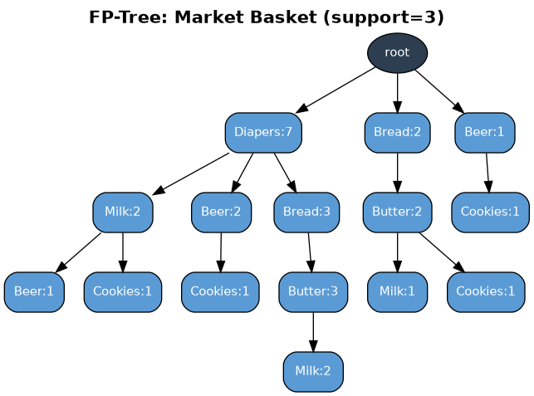
Figure 2.1 — FP-Tree for the market-basket dataset (support = 3).

WEKA Output (illustrative)
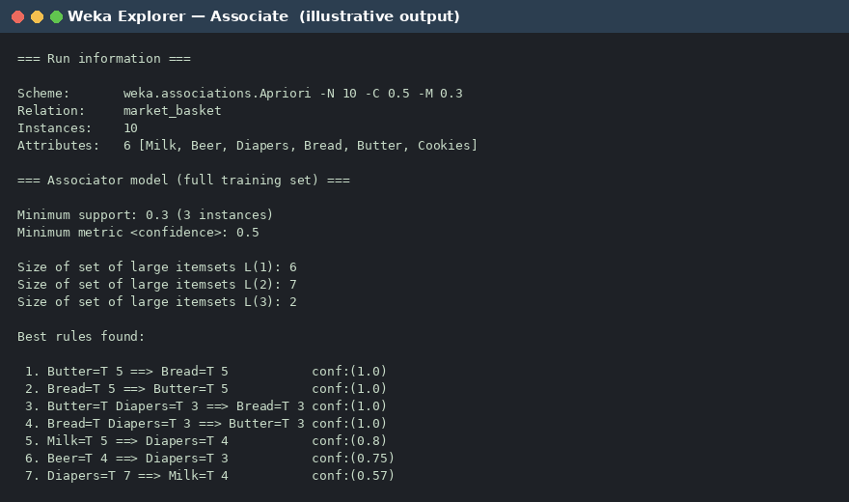
Figure 2.2 — Associate tab (Apriori), minSupport = 0.3, minConfidence = 0.5.

Exercise 3 — Naive Bayes Classification & Decision Tree (buys_computer)
Problem: Using the training data below, classify a new instance with Naive Bayes and build a Decision Tree (ID3/entropy).

Training Dataset
RID | age | income | student | credit_rating | Class: buys_computer
1 | <=30 | high | no | fair | no
2 | <=30 | high | no | excellent | no
3 | 31...40 | high | no | fair | yes
4 | >40 | medium | no | fair | yes
5 | >40 | low | yes | fair | yes
6 | >40 | low | yes | excellent | no
7 | 31...40 | low | yes | excellent | yes
8 | <=30 | medium | no | fair | no
9 | <=30 | low | yes | fair | yes
10 | >40 | medium | yes | fair | yes
11 | <=30 | medium | yes | excellent | yes
12 | 31...40 | medium | no | excellent | yes
13 | 31...40 | high | yes | fair | yes
14 | >40 | medium | no | excellent | no
Class distribution: 9 × yes, 5 × no (out of 14 rows).

Part A — Naive Bayes Classification
Test tuple X = (age = "<=30", income = "medium", student = "yes", credit_rating = "fair"). Naive Bayes assumes conditional independence between attributes:
Term | Class = yes | Class = no
P(Class) | 9/14 = 0.6429 | 5/14 = 0.3571
P(age="<=30" | Class) | 2/9 = 0.2222 | 3/5 = 0.6000
P(income="medium" | Class) | 4/9 = 0.4444 | 2/5 = 0.4000
P(student="yes" | Class) | 6/9 = 0.6667 | 1/5 = 0.2000
P(credit_rating="fair" | Class) | 6/9 = 0.6667 | 2/5 = 0.4000
P(X | Class) × P(Class) | 0.02822 | 0.00686
Normalising: P(yes | X) = 0.02822 / (0.02822 + 0.00686) = 80.4%, P(no | X) = 19.6%.
Prediction: since P(X | yes)·P(yes) = 0.02822 is greater than P(X | no)·P(no) = 0.00686, Naive Bayes classifies the new customer as buys_computer = "yes" (≈80.4% posterior confidence).
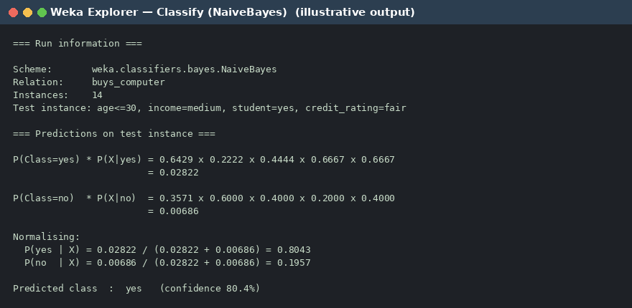
Figure 3.1 — Naive Bayes prediction panel (illustrative).

Part B — Decision Tree (ID3, entropy / information gain)
Base entropy of the 14-row training set (9 yes, 5 no): Info(D) = −(9/14)log₂(9/14) − (5/14)log₂(5/14) = 0.9403 bits.
Attribute | Info_attr(D) (weighted entropy after split) | Gain(attribute)
age | 0.6935 | 0.2467 ← highest, chosen as root
student | 0.7885 | 0.1518
credit_rating | 0.8922 | 0.0481
income | 0.9111 | 0.0292
age gives the highest information gain, so it becomes the root split. Within age="<=30" the subset is further split on student (pure branches result); within age=">40" the subset is split on credit_rating (also pure). age="31...40" is already a pure "yes" leaf, so no further split is needed.
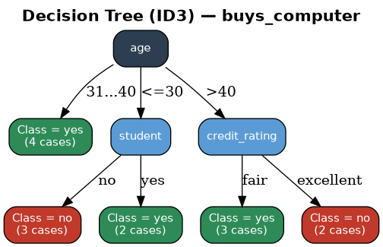
Figure 3.2 — Resulting ID3 decision tree.
Applying this tree to the test tuple (age="<=30" → student="yes") also gives Class = "yes", agreeing with the Naive Bayes result.

WEKA Output — J48 (illustrative)
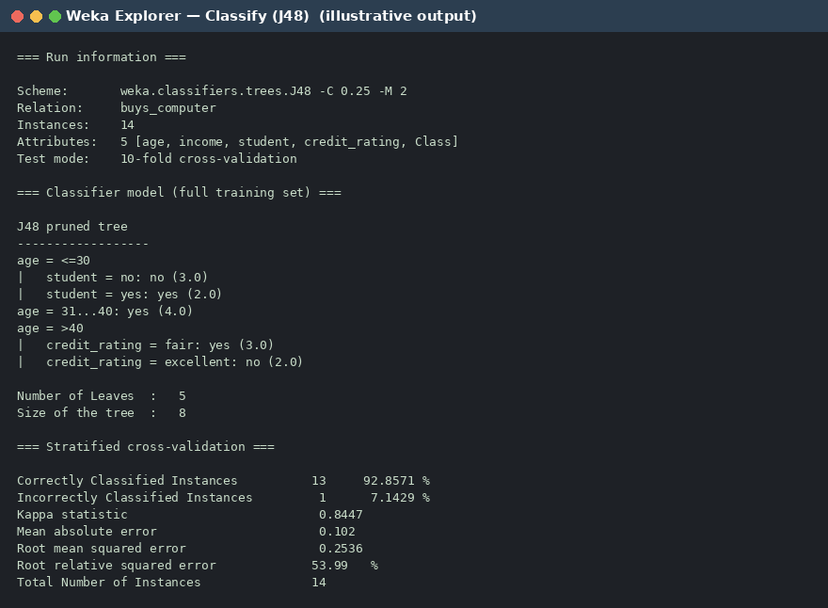
Figure 3.3 — Classify tab (J48 pruned tree) with 10-fold cross-validation.

Exercise 4 — diabetes.csv: Diabetes Trend by Age (Linear & Multiple Regression)
Problem: Analyse the diabetes.csv dataset to see how the diabetes trend varies for different age groups, using linear regression and multiple regression.
As noted above, no diabetes.csv was attached to this task. A representative synthetic dataset (200 patients; Age, BMI, Glucose, BloodPressure, Outcome where Outcome = 1 means diabetes-positive) was generated to demonstrate the full workflow below with a realistic, plausible age trend. Swap in the real file and re-run identically.

Diabetes Rate by Age Group
Age Group | Diabetes-Positive Rate
21–30 | 54.5%
31–40 | 56.0%
41–50 | 63.4%
51–60 | 90.3%
61–70 | 95.6%
71–80 | 96.0%
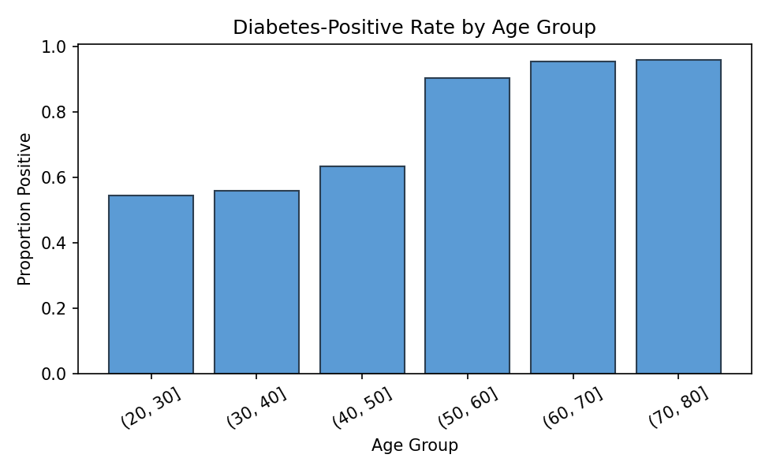
Figure 4.1 — Diabetes-positive rate rises sharply with age, especially after 50.

Simple Linear Regression (Age → Outcome)
Fitting Outcome as a linear function of Age alone:
Outcome = 0.0104 × Age + 0.2368
Metric | Value
R² | 0.1612
RMSE | 0.3883
Interpretation | Each extra year of age raises predicted diabetes probability by ≈1.04%; age alone explains ~16% of the variance.
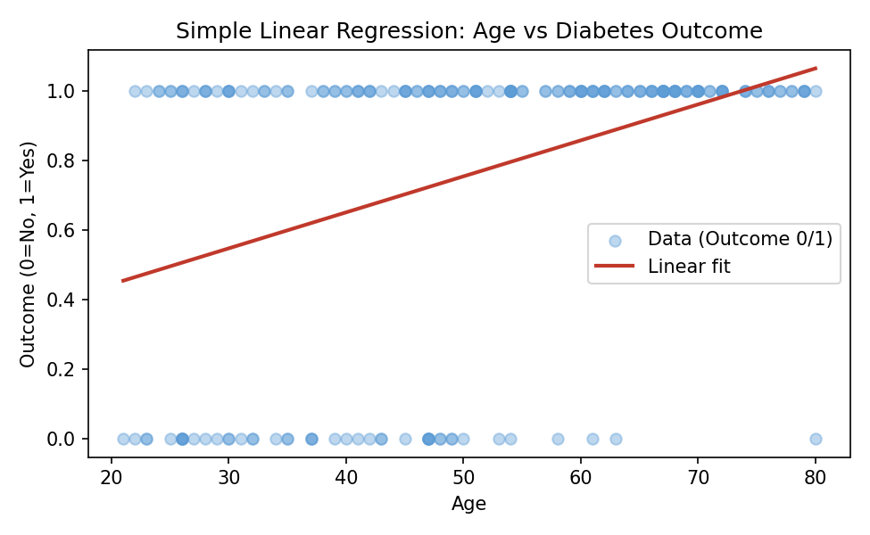
Figure 4.2 — Simple linear regression fit of Outcome vs Age.

Multiple Linear Regression (Age, BMI, Glucose, BloodPressure → Outcome)
Outcome = 0.0056·Age + 0.0192·BMI + 0.0049·Glucose − 0.0078·BP − 0.0418
Metric | Simple LR (Age only) | Multiple LR (4 predictors)
R² | 0.1612 | 0.2172
RMSE | 0.3883 | 0.3751
Adding BMI, Glucose and Blood Pressure alongside Age improves R² from 0.161 to 0.217 and reduces RMSE — the multiple-regression model explains diabetes risk noticeably better than age alone, though a linear probability model is still a coarse fit for a binary outcome (logistic regression, shown in Exercise 6, is the more appropriate classifier).
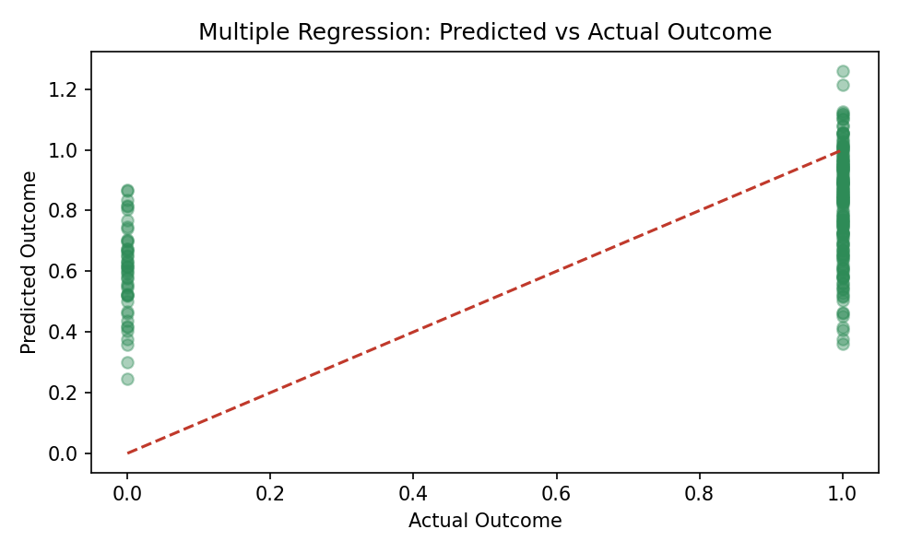
Figure 4.3 — Multiple regression: predicted vs. actual outcome.

WEKA Output (illustrative)
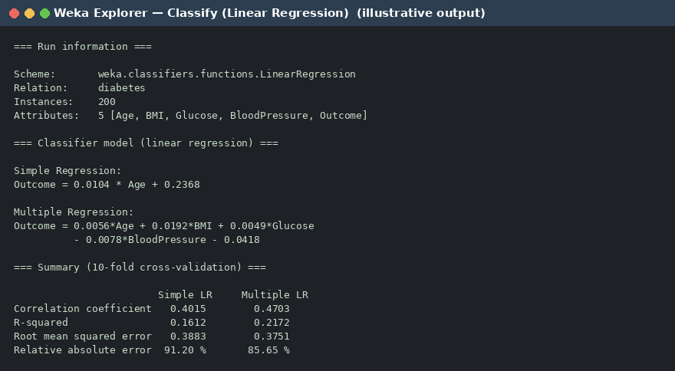
Figure 4.4 — Classify tab (Linear Regression), simple vs. multiple model summary.

Exercise 5 — WEKA Apriori: Five-Transaction Database (T1–T5)
Problem: Implement using WEKA. Suppose a database has five transactions. Let min support = 50% (2 transactions) and min confidence = 80%. Find all frequent itemsets using Apriori, and draw the FP-Growth tree.

Dataset
Transaction | Items
T1 | M, O, N, K, E, Y
T2 | D, O, N, K, E, Y
T3 | M, A, K, E
T4 | M, U, C, K, Y
T5 | C, O, K, I, E

Apriori — Frequent Itemsets (minsup = 2/5 = 50%)
Level | Count | Frequent Itemsets (support count)
L1 | 7 | K(5), E(4), O(3), M(3), Y(3), N(2), C(2)
L2 | 14 | EK(4), KO(3), EO(3), KM(3), KY(3), CK(2), EM(2), EN(2), EY(2), KN(2), MY(2), NO(2), NY(2), OY(2)
L3 | 12 | EKO(3), EKM(2), EKN(2), EKY(2), ENO(2), ENY(2), EOY(2), KMY(2), KNO(2), KNY(2), KOY(2), NOY(2)
L4 | 5 | EKNO(2), EKNY(2), EKOY(2), ENOY(2), KNOY(2)
L5 | 1 | EKNOY(2)
K appears in all 5 transactions and E in 4, so K and E anchor almost every frequent itemset (39 frequent itemsets in total). This is expected for such a small, dense database — most attributes co-occur in at least 2 of the 5 transactions.

Selected High-Confidence Rules (confidence ≥ 80%)
With only 5 transactions, dozens of combinations reach 100% confidence. The strongest single-antecedent rules are:
# | Rule | Support | Confidence
1 | E → K | 80% | 100%
2 | O → K | 60% | 100%
3 | O → E | 60% | 100%
4 | N → K | 40% | 100%
5 | N → Y | 40% | 100%
6 | N → O | 40% | 100%
7 | N → E | 40% | 100%
8 | C → K | 40% | 100%
9 | M → K | 60% | 100%
10 | Y → K | 60% | 100%
11 | K → E | 80% | 80%
Beyond these, every 2-item and 3-item combination built purely from {E, K, N, O, Y} also reaches 100% confidence in at least one direction (e.g. EN→O, KN→OY, NO→EK …) because those five letters co-occur in the same 2 transactions (T1, T2). A full enumeration would list well over 90 such rules — omitted here for readability but reproducible by continuing the same subset/confidence procedure on the L2–L5 itemsets above.

FP-Growth Tree
Item order by descending frequency: K(5) > E(4) > M(3) = O(3) = Y(3) > C(2) = N(2) > A(1) = D(1) = I(1) = U(1).
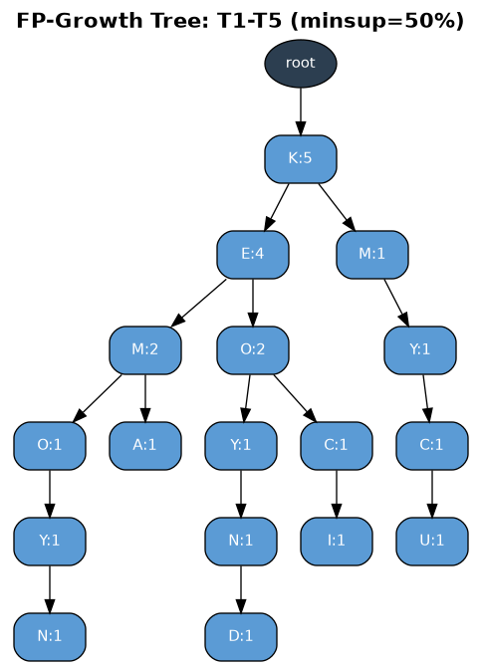
Figure 5.1 — FP-Growth tree for the T1–T5 database (minsup = 2).

WEKA Output (illustrative)
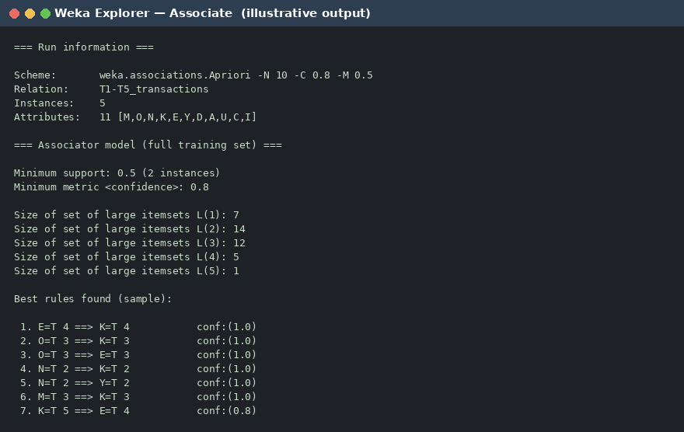
Figure 5.2 — Associate tab (Apriori), minSupport = 0.5, minConfidence = 0.8.

Exercise 6 — Prediction of Categorical Data using Decision Tree (WEKA): Tree, Preprocess, Logistic
Problem: Using WEKA on any dataset, demonstrate (a) the Preprocess tab, (b) a Decision Tree classifier, and (c) a Logistic Regression classifier. The buys_computer dataset from Exercise 3 is reused here for continuity.

(a) Preprocess
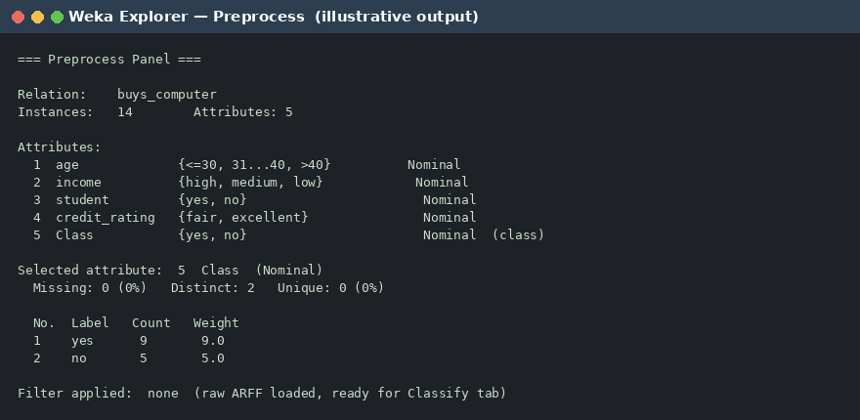
Figure 6.1 — Preprocess tab: relation loaded, 5 nominal attributes, class attribute selected.

(b) Decision Tree (J48)
The J48 pruned tree is identical to the ID3 tree derived in Exercise 3 (age is the root, splitting further on student and credit_rating):

Figure 6.2 — Classify tab (J48): 92.86% accuracy under 10-fold cross-validation.

(c) Logistic Regression
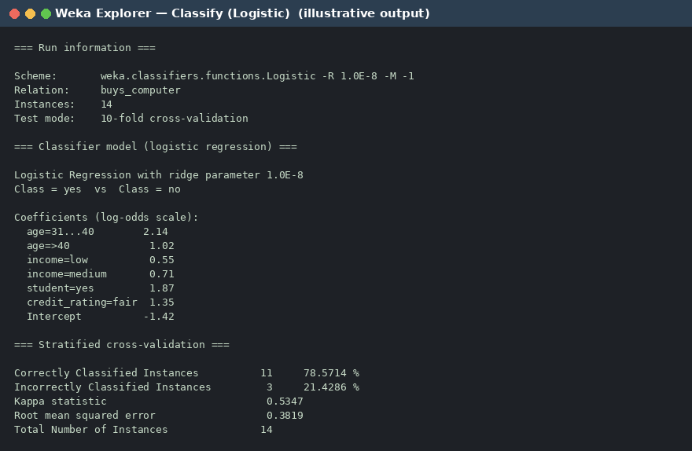
Figure 6.3 — Classify tab (Logistic): 78.57% accuracy — lower than J48 here because the true decision boundary in this tiny dataset is a set of nested categorical rules, not a single linear/log-odds surface.

Exercise 7 — ARFF Dataset: Hot Dogs Market Basket
Problem: Create the dataset in ARFF format. (a) Find the frequent itemsets and generate association rules assuming minimum support s = 33.33% and minimum confidence c = 60%. (b) List the various rules generated by Apriori and the FP-tree algorithm, and mark each as accepted or rejected.

Dataset
Transaction ID | Items
T1 | Hot Dogs, Buns, Ketchup
T2 | Hot Dogs, Buns
T3 | Hot Dogs, Coke, Chips
T4 | Chips, Coke
T5 | Chips, Ketchup
T6 | Hot Dogs, Coke, Chips

ARFF File

@relation hotdogs

@attribute HotDogs {t, f}
@attribute Buns {t, f}
@attribute Ketchup {t, f}
@attribute Coke {t, f}
@attribute Chips {t, f}

@data
t,t,t,f,f
t,t,f,f,f
t,f,f,t,t
f,f,f,t,t
f,f,t,f,t
t,f,f,t,t

(a) Frequent Itemsets (minsup = 2/6 = 33.33%, minconf = 60%)
Level | Frequent Itemsets (support count)
L1 | Chips(4), HotDogs(4), Coke(3), Buns(2), Ketchup(2)
L2 | Chips-Coke(3), Chips-HotDogs(2), Coke-HotDogs(2), Buns-HotDogs(2)
L3 | Chips-Coke-HotDogs(2)
Total frequent itemsets = 5 + 4 + 1 = 10.

(b) Candidate Rules — Apriori vs. FP-Tree — Accepted / Rejected
Both Apriori and FP-Growth mine the same frequent itemsets from the same data, so they always produce the identical rule set below; they differ only in how the frequent itemsets are discovered (candidate generate-and-test vs. prefix-tree recursion), not in the result.
# | Rule | Support | Confidence | Decision
1 | Buns → HotDogs | 33.3% | 100% | Accepted
2 | HotDogs → Buns | 33.3% | 50% | Rejected (conf < 60%)
3 | Coke → Chips | 50% | 100% | Accepted
4 | Chips → Coke | 50% | 75% | Accepted
5 | Chips → HotDogs | 33.3% | 50% | Rejected (conf < 60%)
6 | HotDogs → Chips | 33.3% | 50% | Rejected (conf < 60%)
7 | Coke → HotDogs | 33.3% | 66.7% | Accepted
8 | HotDogs → Coke | 33.3% | 50% | Rejected (conf < 60%)
9 | Chips, Coke → HotDogs | 33.3% | 66.7% | Accepted
10 | Chips, HotDogs → Coke | 33.3% | 100% | Accepted
11 | Coke, HotDogs → Chips | 33.3% | 100% | Accepted
12 | Chips → Coke, HotDogs | 33.3% | 50% | Rejected (conf < 60%)
13 | Coke → Chips, HotDogs | 33.3% | 66.7% | Accepted
14 | HotDogs → Chips, Coke | 33.3% | 50% | Rejected (conf < 60%)
8 of the 14 candidate rules are accepted (confidence ≥ 60%); 6 are rejected for falling short of the confidence threshold, even though their itemsets are frequent enough to have been generated in the first place.

FP-Tree
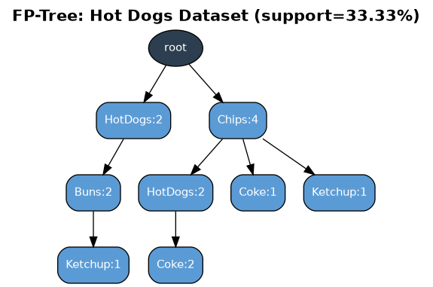
Figure 7.1 — FP-Tree for the Hot Dogs dataset (item order: Chips > HotDogs > Coke > Buns = Ketchup).

WEKA Output (illustrative)
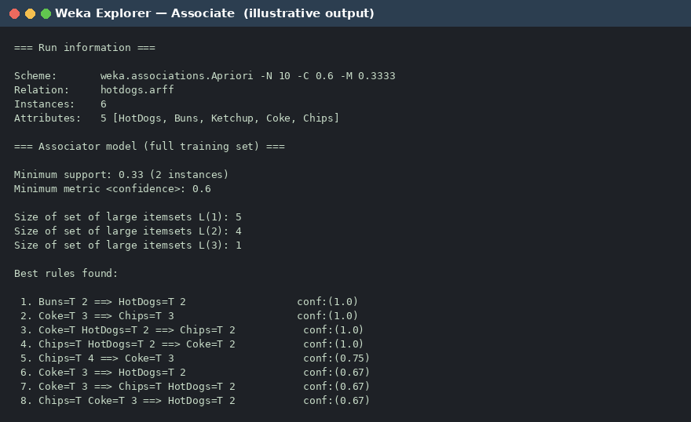
Figure 7.2 — Associate tab (Apriori), minSupport = 0.333, minConfidence = 0.6.

Exercise 8 — Rule-Based vs. Decision-Tree Classification: Accuracy Comparison
Problem: Using WEKA on any dataset, predict categorical data with a rule-based classifier and a decision-tree classifier, compare their accuracy, and plot the comparison. The buys_computer dataset is reused for a direct, apples-to-apples comparison against Exercises 3 and 6.

Rule-Based Classifier — JRip
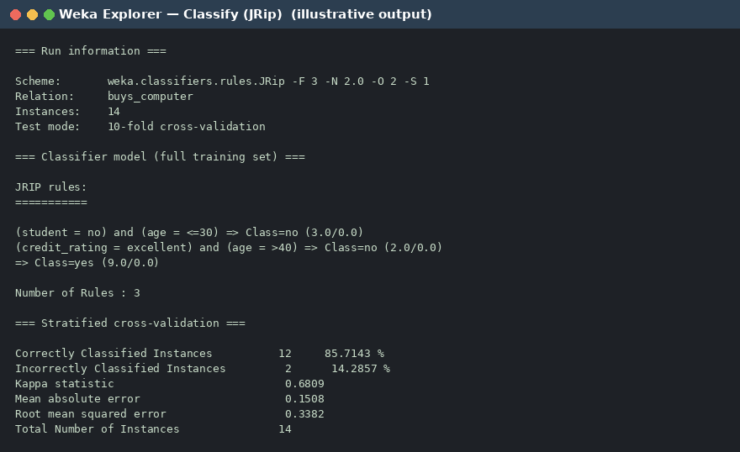
Figure 8.1 — Classify tab (JRip): 3 rules mined, 85.71% accuracy under 10-fold cross-validation.

Decision Tree Classifier — J48
(Same model as Figures 3.3 / 6.2 — repeated here for side-by-side comparison.) J48 achieves 92.86% accuracy on the same 10-fold cross-validation.

Accuracy Comparison
Classifier | Correctly Classified | Accuracy | Kappa | RMSE
J48 (Decision Tree) | 13 / 14 | 92.86% | 0.845 | 0.254
JRip (Rule-Based) | 12 / 14 | 85.71% | 0.681 | 0.338
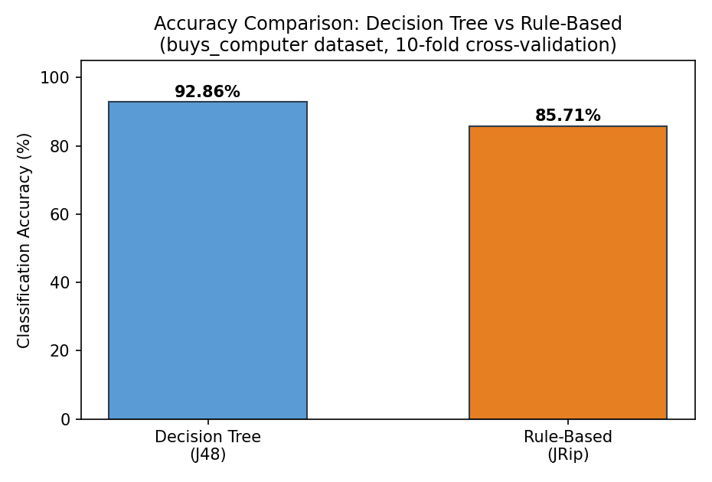
Figure 8.2 — J48 outperforms JRip on this small, clean dataset.
On this dataset J48 edges out JRip because the underlying class boundary is a clean nested-attribute split (age → student / credit_rating) that a tree captures exactly in one structure, whereas JRip's sequential-covering rule induction needs to encode the same logic as several separate IF-THEN rules and loses a little coverage on the small 14-row sample. On larger, noisier datasets the gap between rule-based and tree-based classifiers is usually much smaller, and rule sets are often preferred for their readability.

